**ANALYSIS MODEL**

* Analysis model operates as a link between system description and design model.
* In analysis model, information, functions and behaviour of the system is defined and these are translated to the architecture, interface and components level design in ‘design modeling’.

**Architcture:**

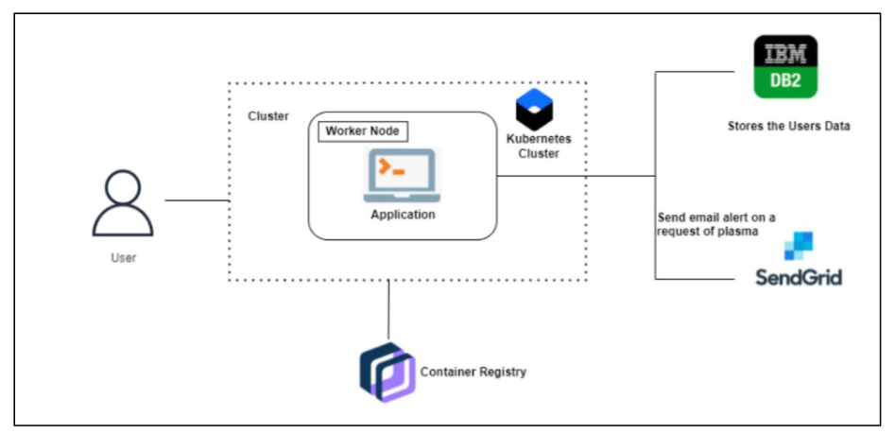

**Interface:**

**  
